5-2 Project One
IT-423 Computing as a Service
Tamani Harrison
Southern New Hampshire University
Instructor Sean Stinehour
8/1/2026

Competency
In this project, you will demonstrate your mastery of the following competencies:
- Implement a cloud-based system that meets organizational needs
- Interface with cloud-based databases to support organizational operations

Scenario
Imagine that you are a solutions architect at an educational technology start-up organization called Your Online Database Architecture for Education (YODAE). YODAE hired you to design its cloud database for teachers in the K–12 education system. The cloud-based IT system and database that you design will help teachers manage their classrooms and create online learning experiences for their students. The database should store information about teachers, students, and classrooms. For this project, you will design the architecture of the database system by creating an entity relationship diagram (ERD). Then you will implement your design by creating a cloud database system. The cloud database system’s architecture consists of a database, web server, webpage, and client- or server-side scripting.
Review the YODAE Business Case in the Supporting Materials section to learn about YODAE and how your cloud solution will meet the organization’s needs and operations. The Module Five Resources section includes links to technical support resources you may need to complete the assignment.

Directions
To complete this project, you must address the following rubric criteria:
- Entity Relationship Diagram: Create an ERD that meets organizational and user needs.
  - The ERD must show your cloud database system’s architecture as part of the cloud-based database design.
  - To create your ERD, refer to the YODAE ERD Example in the Supporting Materials section. This example already includes some components of your diagram. Add to this diagram by including the following components:
    - All of the appropriate entities: What entities described in the business scenario does the ERD need to include?
    - All of the appropriate attributes: What are five attributes for each entity?
    - Necessary relationships: How will the relationships between the entities be accurately presented in the diagram?
- Explanation of Entity Relationship Diagram: Explain how the components of the ERD will meet the organizational needs.
  - How does your diagram meet the needs of YODAE and its clients.
  - Explain the entities, attributes, and relationships depicted in your diagram.
You will create the architecture of the cloud-based application you designed in the AWS console through the same uCertify Hands On Lab 3.2.1 you used for Project One Milestone Two. To implement this, you are required to complete the following tasks:
- Set Up Virtual Server: Create an EC2 instance.
  - Take screenshots to confirm that you have successfully created your EC2 instance. You can access the webpage by pointing your web browser to the IP address (for example: http://3.93.174.154) of your server, which is found in the EC2 dashboard for your instance.
- Implement Database Tables: Implement database tables that match the ERD.
  - Create the database tables that you designed in your ERD, which include all columns and keys.
  - Take a screenshot to confirm that you have created the appropriate databases depicted in your ERD.
- Data Manipulation: Manipulate the data in these suggested ways.
  - After you have created your new database tables, manipulate the data by completing the following actions and taking screenshots of the webpage after each “modification” to show that each action has been successfully completed:
    - Insert some test data into each table.
    - Show a Delete statement removing a course from the Courses table.
    - Show a statement that changes the entry_year for a particular student.
- Interface With Database: Use the provided code to view the data represented in the tables.

Entity Relationship Diagram:
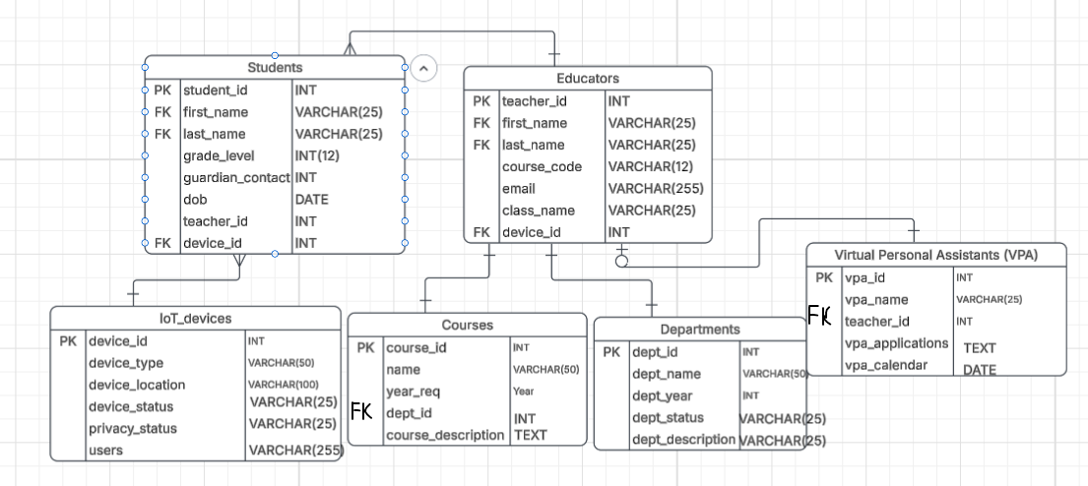
Explanation of Entity Relationship Diagram:
This ERD diagram reflects YODAE’s priorities for a better management system. It provides educators, administrators, and students with a simplified user experience that supports the organization's needs. Each primary key addresses specific requirements set by YODAE. The student entity stores vital student data. The educator entity stores data related to teachers. The IoT Devices entity stores information about Internet of Things devices used by students and educators. The course & the department sections can improve classroom management by highlighting the needs of students and teachers across the school. The virtual personal assistants are useful for educators to streamline their daily activities by easily retrieving information & planning academic calendars.
The student section contains student identification, first & last names, grade levels, guardian contact info, current teachers, date of birth & accessible IoT devices. This information helps school administrators & educators easily track student information & device permissions across the school database. If a student is transferred to another school, their device ID can be transferred to another student in need of an IoT device. This mitigates potential headaches that could arise from IoT devices being stolen or lost due to poor accountability.
The educator entity contains important information regarding educators, such as their identification, first & last names, curriculum code list, school email addresses, class names, and assigned IoT devices. This information allows schools to identify that an educator is who they claim to be. YODAE clients will enjoy having this information available. It allows them to log important student & teacher information. It also lets them keep an eye on how students & teachers get along via email monitoring.
The Internet of Things device section identifies each device connected to the school network, what kind of device it is, where it is located, who is using it, and the device's status & privacy status. These settings are necessary to prevent rampant misuse of school hardware by both teachers and students. Knowing where the device is and what its status is helps IT staff account for each device & that the devices are being used for their intended purposes. Device type & ID help improve school security by allowing each device on the network to be clearly seen. This allows access controls to be restricted to student & educator’s needs. Each IoT device can be monitored by checking each device's privacy status to make sure there is no breach in the device's privacy configuration.
The virtual personal assistants section identifies VPA ID, VPA name, teacher ID, VPA applications, & VPA calendar. Virtual personal assistants are a major Internet of Things device that YODAE will begin offering to schools. An educator can teach multiple classes, which is why they should use the VPA applications & calendar to keep track of student details & events without breaching privacy. The VPA ID, VPA name, & teacher ID allow materials to be transferred from one department to another if necessary, but the educator's information would remain the same. This YODAE-provided tool can make schools more efficient and secure by helping them transfer educators where they are needed without the need to add or overwrite database credentials.

The course section contains the course ID, name, year requirement, department identification, & course description. The course section benefits YODAE and its clients by providing them with vital information about what subjects & grades they will be teaching each semester. The course ID, name, and year requirement are necessary to know where educators will be placed for the semester. The virtual personal assistant can be configured based on department ID and course description to increase teacher effectiveness by being prepared. It can also benefit students by having a customized learning experience that works to ease the burden on someone who has trouble hearing or seeing while in a classroom.
The department section includes the department ID, department name, department year, department status, and department description. The department section allows YODAE and its clients to identify the needs of their students & teachers by using the department ID, name, and status to categorize each school department better than before. An underfunded program with out-of-date technology can get the attention it deserves by examining the department year & description, which can be used to resolve educational gaps between students by incorporating IoT devices to enhance the learning experience.
The relationships between the entities in the diagram come from IoT devices and big data. A shared IoT device network across public schools requires detailed network planning. The virtual private network can be used by educators to acquire information about students in the event of an emergency or to keep track of the current courses they are teaching and which departments they will be located in. Identification is required to access the IoT device info, like a teacher ID. This would prevent anyone without strict access from accessing the protected data, which is beneficial for meeting the goals of YOADE and its clients.
The IoT devices would be connected to a larger database that requires a student or teacher ID to access the device & configure it to the user's personal needs, like a student who needs to use closed captioning. The students & educators share the foreign keys. Some teachers and students are likely to share the same first and last names. It’s possible that they could share the same device ID, assuming the product has been reused by the school district. This is where VPAs would be useful, as they could be attached to the teacher ID’s to create a unique identification number that removes the chance of teacher names being mixed up with students or other educators. The foreign key under VPAs teacher ID allows the relationship between the two entities to have a one-to-one understanding, as educators retain ownership of their accounts for as long as they are employed. The one-to-one relationship between courses and departments ID shows that educators can be tied to different departments and courses depending on their circumstances.

Set Up Virtual Server:
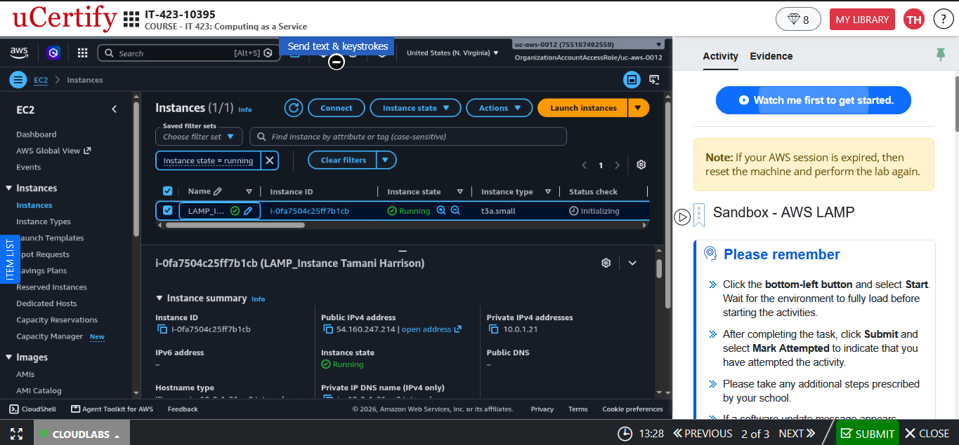 This picture shows that the EC2 instance was successfully created. The EC2 instance was renamed to include the student’s name to show ownership over the instance.
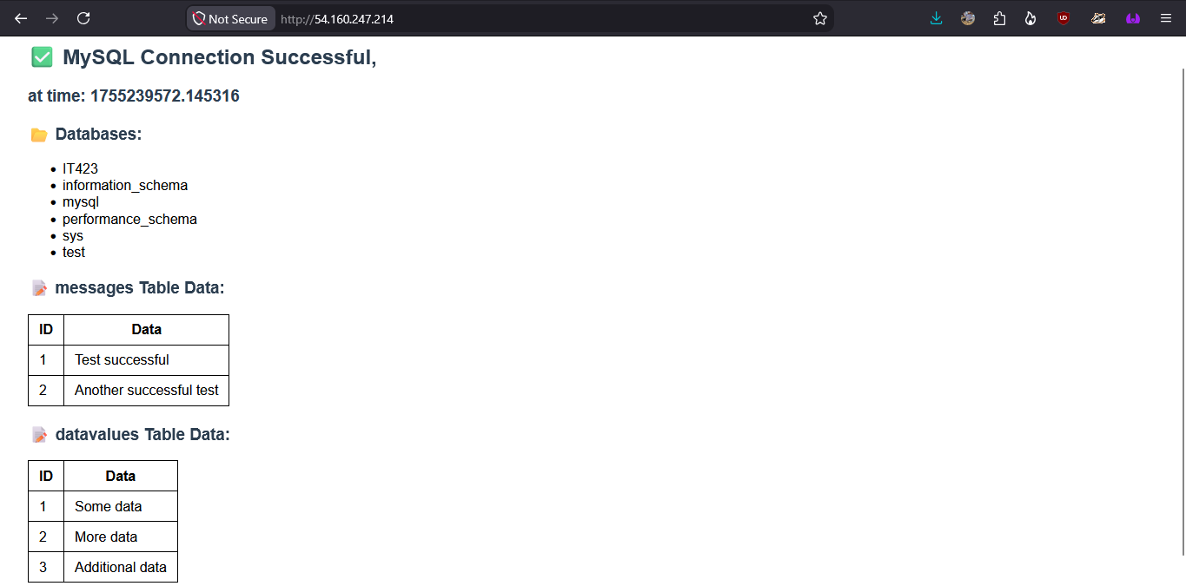This picture shows that the server IP address successfully connects to the MySQL database. This test photo of the server shows that the database is ready to be modified.
Implement Database Tables: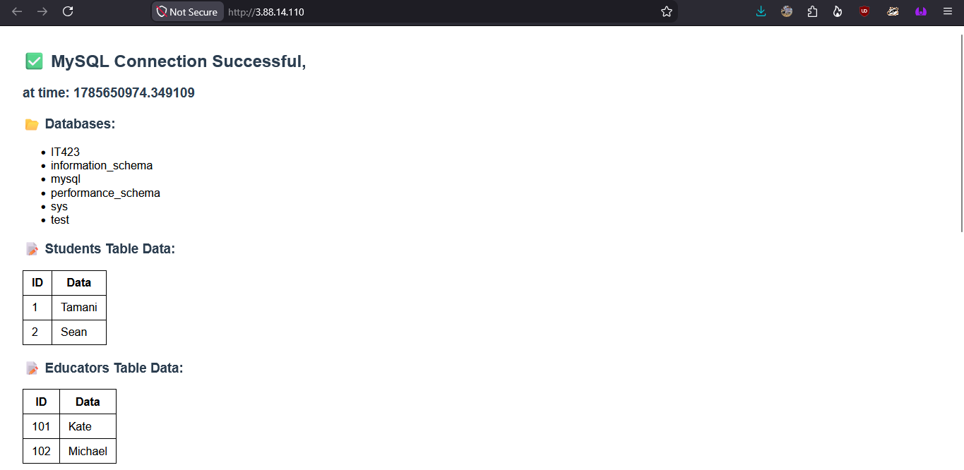
A new EC2 instance was created, but I managed to get the SQL code in. My name is in one of the tables to verify my work. The Student & Educator tables are displayed here along with the ID for each student & educator.
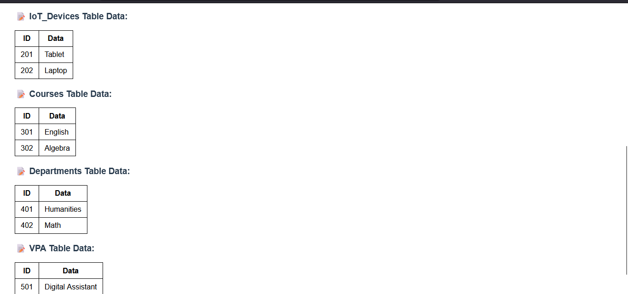
This is a continuation of the previous pic. The IoT devices, course tables, department tables, and a section of the VPA table are visible. Identification is given to each respective data table section.
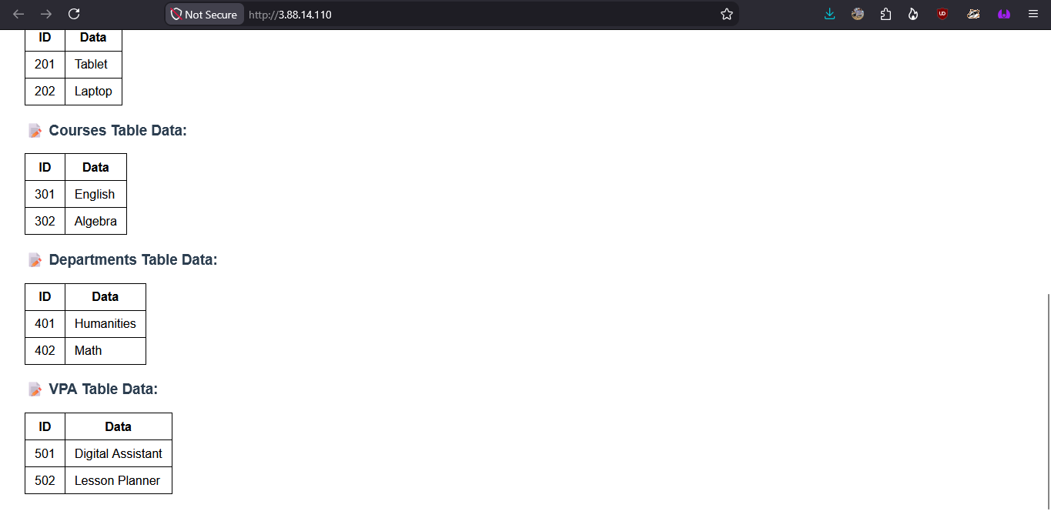
The following shows the entire virtual personal assistants table. Identification & data about each function of the VPA are presented.
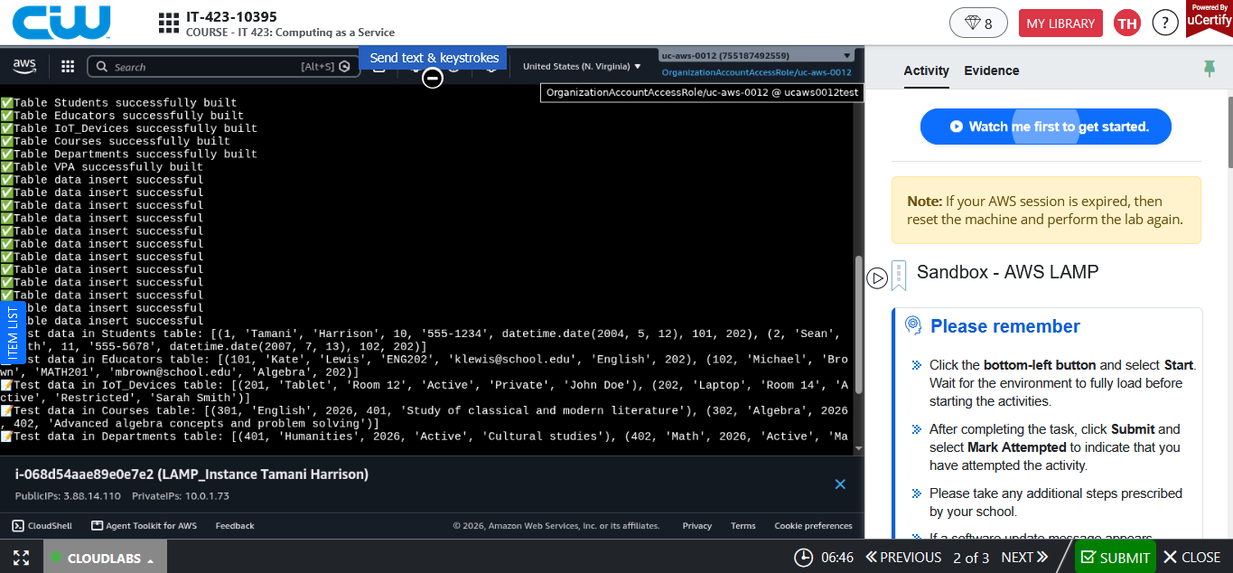The table data was successfully inserted into the EC2 instance terminal. Test data was written in the students, educators, IoT devices, courses, departments, & VPA tables.
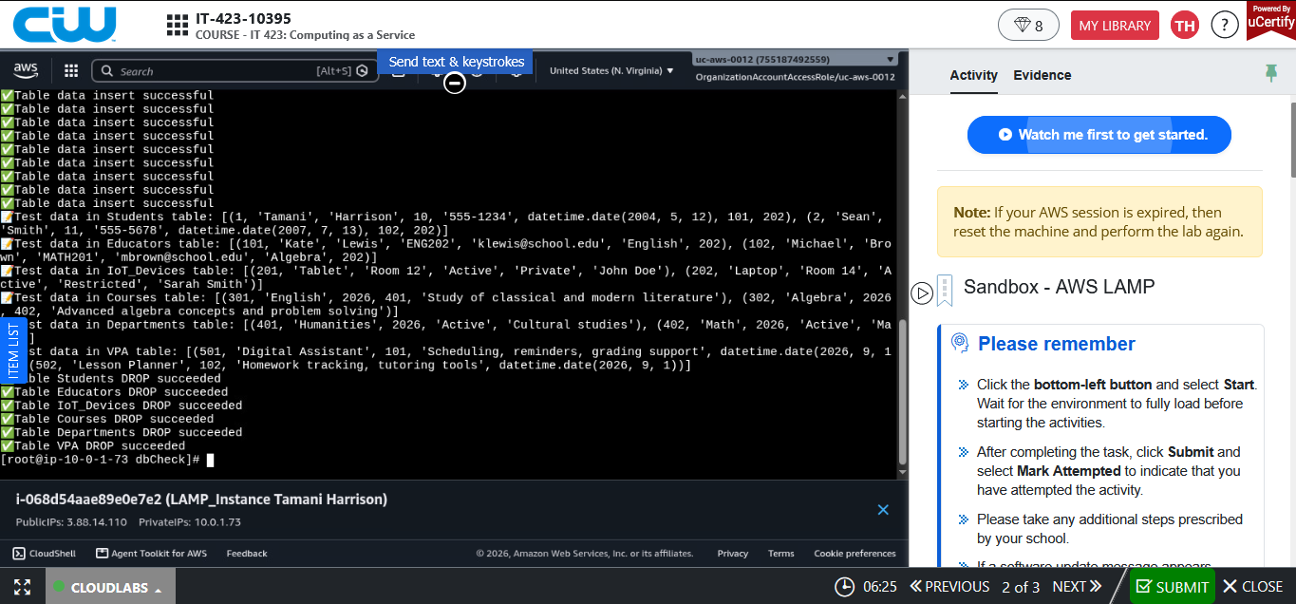
A continuation of the previous picture that shows the table data was successfully inserted into the EC2 terminal.
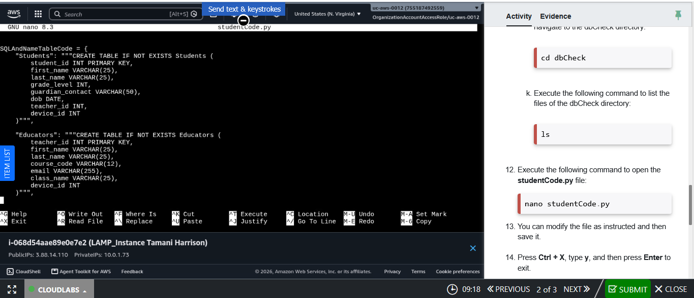
The first half of the SQL code entered into the terminal. This section creates the students and educators tables.
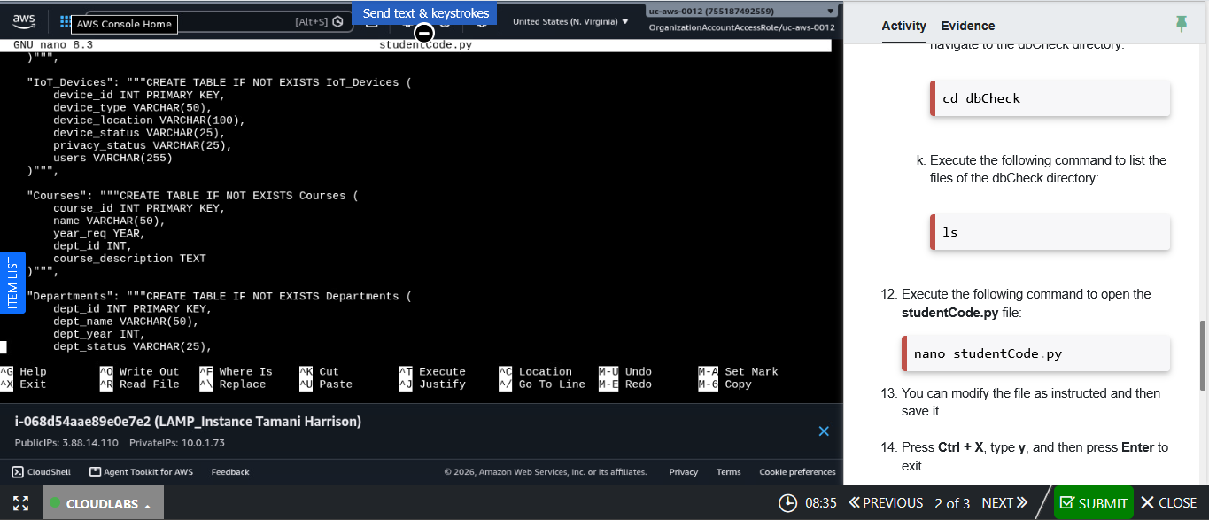
The second portion of the SQL screenshots. The IoT devices, course, and department table were created.

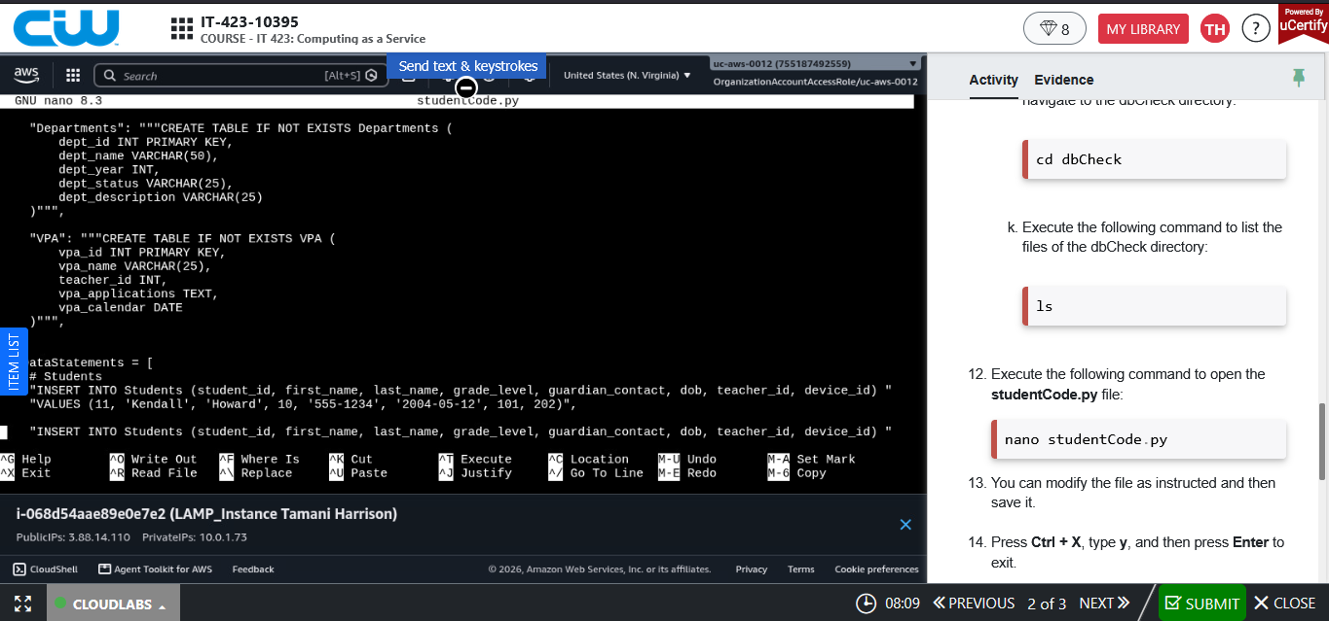
This section shows the virtual private assistants & moves onto the data statements.
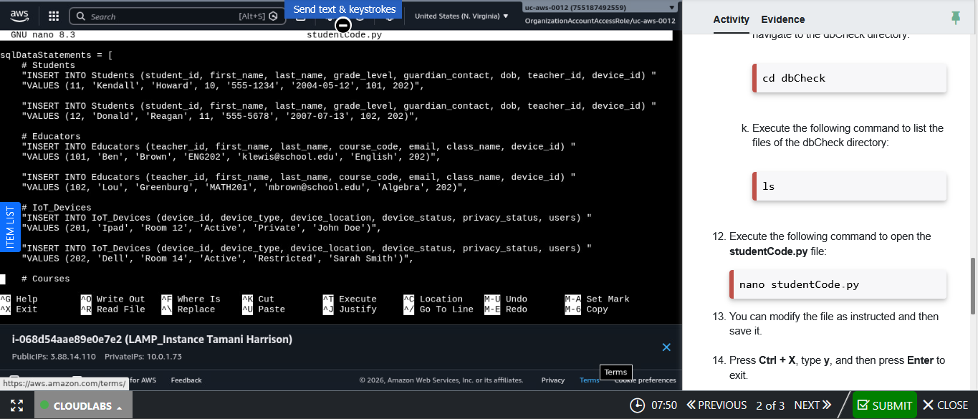
The data statements used are the manipulated versions. Data is being inserted for the students, educators, IoT devices, and courses.
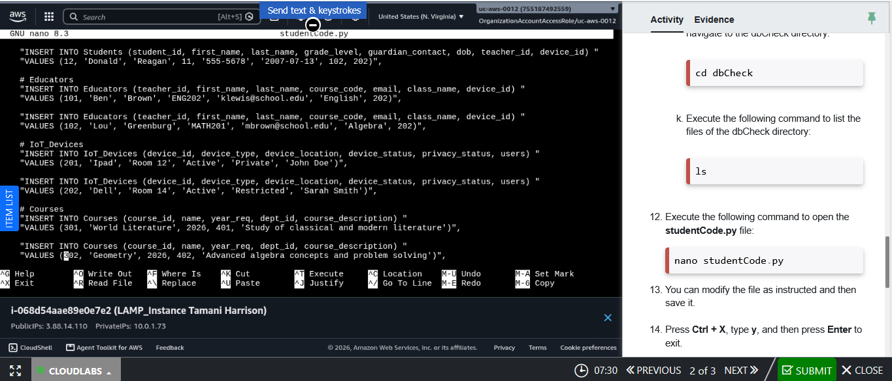
The courses world literature & geometry show data being entered.
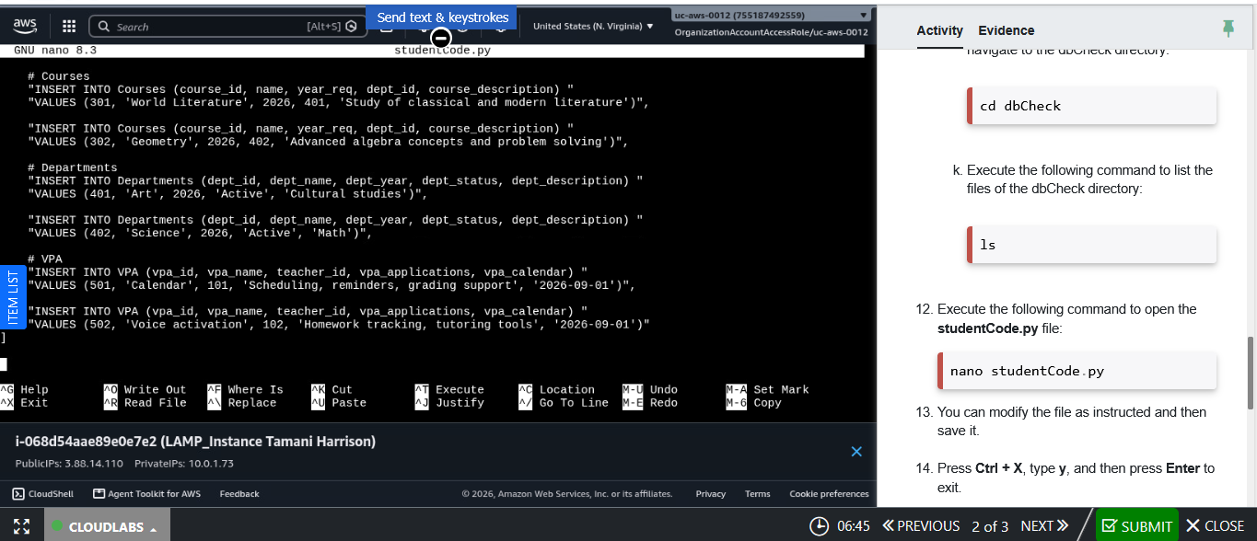
The VPAs show data being inserted into this section. Each section uses a different aspect of the virtual private assistants, such as their calendars and voice activation.
Data Manipulation:
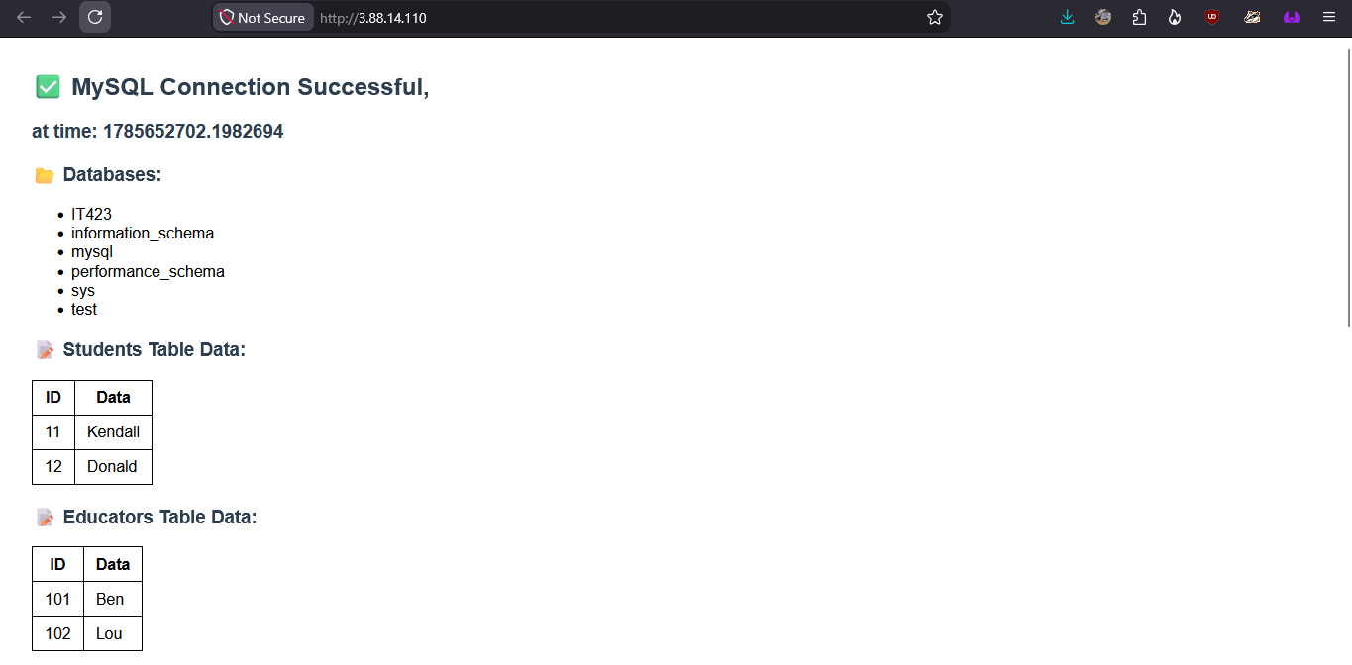
Data has been manipulated with test data. The names of the teachers & students were changed. The Student ID’s were changed to 11 & 12. The educators' IDs were left unchanged.
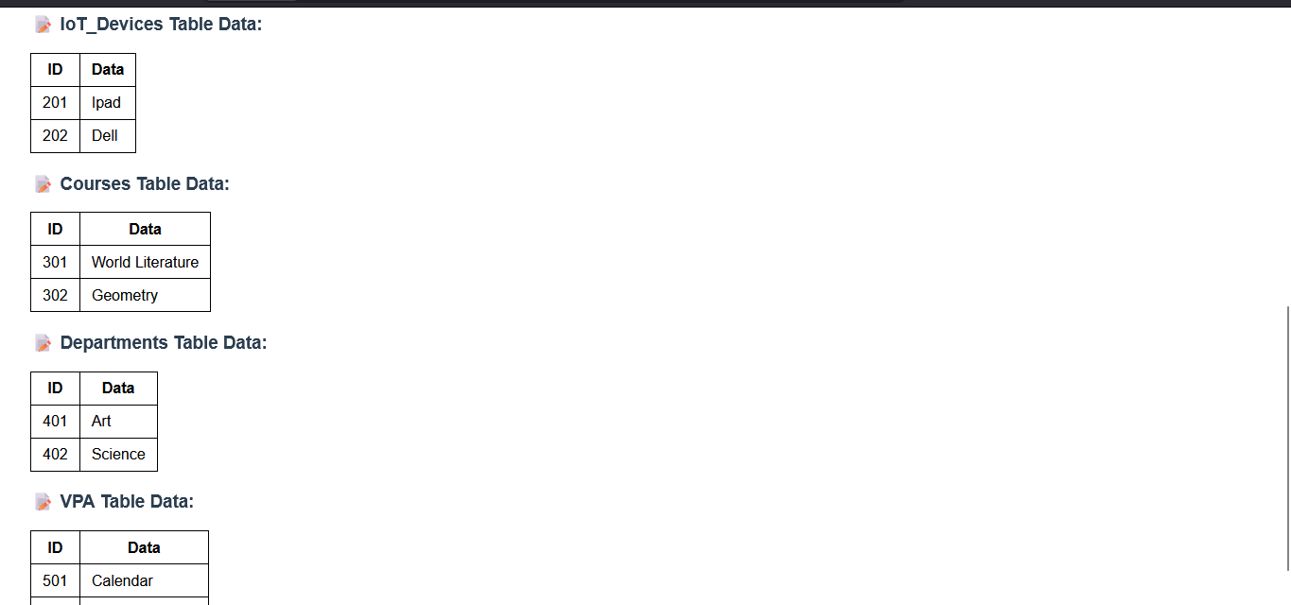
The IoT device table now displays iPad & Dell in place of tablet & laptop. The course section shows world literature & geometry, instead of English and algebra. The departments table has been changed to show art and science, instead of humanities and math. Finally, the virtual private assistant table has been changed to show calendar, instead of digital assistant.
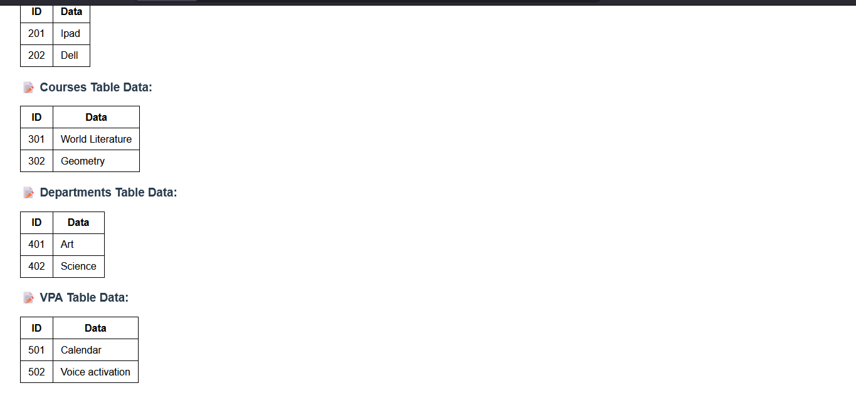
This is a continuation of the last picture. The VPA section under voice activation has been changed from lesson planner to its current state.
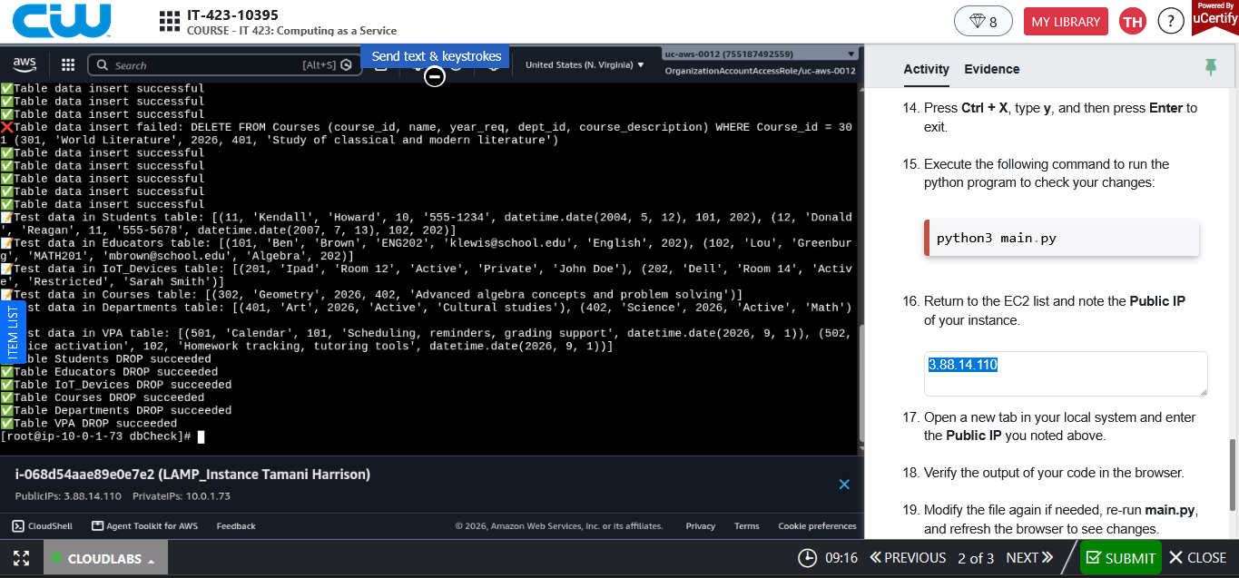
The class was not inserted into the data table. The Delete from statement successfully worked as intended.
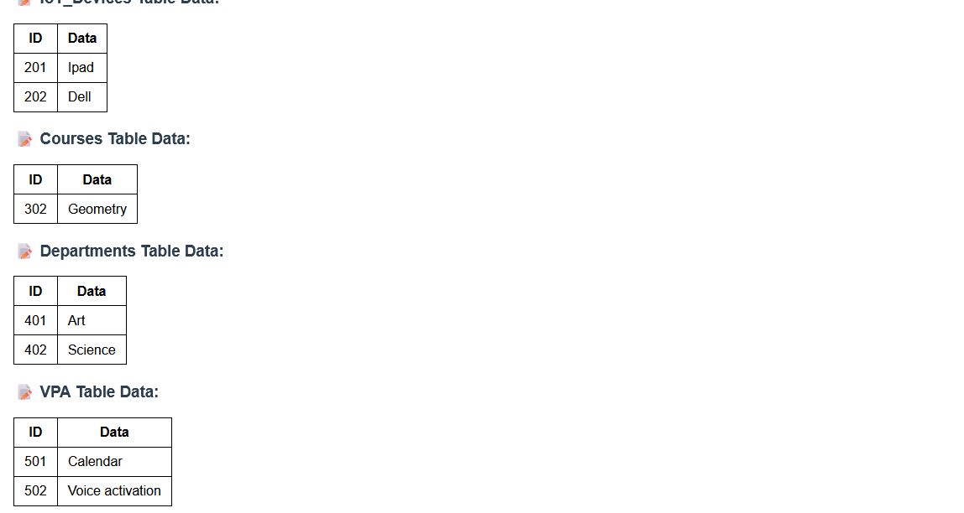
The world literature course has been deleted from the data table. The delete statement removed the course from the table, only leaving geometry.
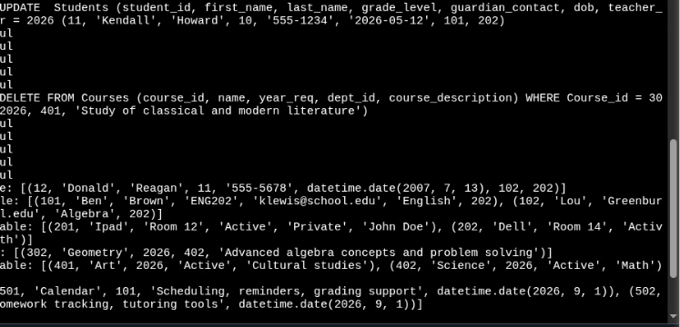The student entry year was updated to 2026 from 2004. The website page does not display years, but the change was acknowledged in the terminal.
Interface With Database:
The IP address code allows for the data represented in the tables to be viewed. http://3.88.14.110/
